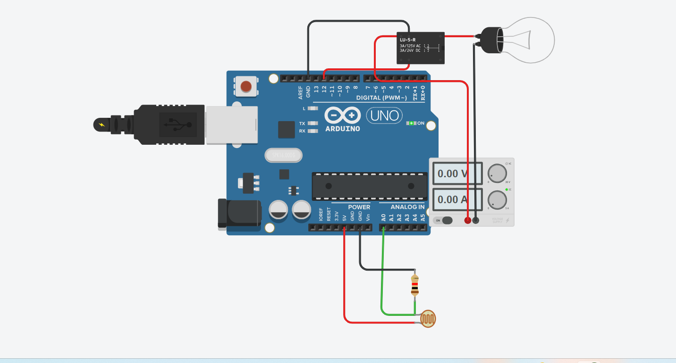

CIRCUIT DIAGRAM:

**CODE:**

// C++ code

void setup()

{

pinMode(A0, INPUT);

Serial.begin(9600);

pinMode(12, OUTPUT);

}

void loop()

{

Serial.println(analogRead(A0));

if (analogRead(A0) < 500)

{

digitalWrite(12, HIGH);

Serial.println("LED HIGH");

} else

{

digitalWrite(12, LOW);

Serial.println("LED LOW");

}

delay(10); // Delay a little bit to improve simulation performance

}

**WORKING DEMO:**

